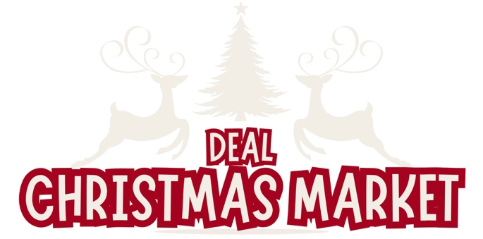

Deal Christmas Market 2026
Event Traders/Venders Compliance Checks

All traders, vendors, and third-party event providers are required to complete the Trader/Vendor Compliance Check Sheet and upload it as part of their application form.

Business Information
Business Name
Business Type
Goods/Services Sold
Registered Business Address
Companies House Number (if registered)
Business Payment Methodes | E.g Cash/Card
How many staff members will be attending?
How many staff parking permits are required?
Pitch Information (if providing own pitch)
Pitch Size in meters | E.g 3m X 3m gazebo
Pitch type | Gazebo / Van / Trailer Van /
Do you have your own electricity supply? If so please provide us with your risk assessment.
Do you require electricity supply other than lighting?
Point of Contact Information
Full Name
Email
Phone Number
Compliance Checks | Tick All That Apply - These will be checked on the event dates
Appropriate Fire Extinguisher
Fire Blanket (food venders only)
5 Million Minimum Public Liability
Food Hygiene Certificate (food venders only)
Food Hygiene Rating (food venders only)
Stall/Pitch Risk Assessment
Trade Waste Agreement
Photograthic ID (point of contact)

Please ensure that you upload this document along with all other required document to the trader’s application form via our website. www.DealChristmasMarket.co.uk/traders

